**Employee Loan Management System (EPMS) Documentation**

**1. Project Description**

* Introduction
* Aim of system
* Scope of system

**2. Business Rules**

* Eligibility criteria
* Loan application process
* Approval and disbursement
* Repayment

**3. Project Functionalities**

* User authentication and authorization
* Employee profile management
* Loan application
* Application submission, tracking and verification
* Terms and condition approval
* Notifications and reminders
* User and admin dashboard

**4.** **Development Life cycle**

* Requirements gathering and analysis
* Application design
* Implementation
* Testing
* Deployment
* Maintenance

**5.** **System analysis and design**

* Class Diagram
* Use case diagram
* Activity diagram

**Project Description**

**Introduction:**

The Employee Loan Application Software is designed to managing employee loan applications within an organization with integrity. As organizations grow, the need for an efficient system to handle loan requests becomes crucial to ensure a smooth, transparent, and compliant process. This software will enable employees to easily submit loan applications and allow administrators to manage, review, and approve these applications with minimal manual interferences. The software user-friendly interface, automated workflows, and reliable tracking systems are designed to streamline the loan application process. Key features of the Employee Loan Application Software include a web-based interface for application submission, automated approval workflows, real-time notifications, comprehensive reporting, and analytics tools. This system is designed to improve transparency, communication, and record-keeping, ultimately gain both employees and administrators by providing a seamless and efficient loan application experience.

**Aim of System:**

* Streamline the Application Process
* Automate Workflow Management
* Enhance Transparency and Communication
* Ensure Compliance and Accuracy
* Facilitate Financial Planning
* Provide Analytical Insights

**Scope:**

The scope of this system is to deliver efficient, smooth loan amounts to the employees of any small scale and large-scale organizations. The Employee Loan Application Software is designed to provide a full solution for managing employee loan requests, from initial application to final approval and distribution. The system will also provide tracking and reporting functionalities to monitor the status of loan applications and repayments.

**Business Rules**

**Eligibility criteria:**

* **Employment Status**: Only current full-time employees are eligible
* **Minimum Service Period**: Employees must have completed a minimum service period (e.g., 2 months) to apply.
* **Credit History**: Employees must have a satisfactory credit history without defaults or bankruptcies, and employee should have paid all the dues within timeframe.

**Loan Application Process:**

* Application Submission: Applications must be submitted through the official app or platform provided by the company.
* Documentation: Required documents (e.g., proof of employment, salary slips) must be submitted along with the application.
* Loan Amount: Employees can apply for a loan within a specified range (As per CIBIL Score).

**Approval and Disbursement:**

* Approval Authority: Loan approvals are subject to review and approval by designated personnel (e. g. Admin).
* Decision Timeframe: Employees will be informed of the loan decision within a specified timeframe through notification and mail. (e.g., 1 business day).
* Disbursement: Approved loans will be disbursed directly to the employee’s designated bank account within 15-20mins.

### Repayment:

* **Repayment Terms**: Loans must be repaid in equal monthly instalments or a specified period (e.g., 12 months).
* **Interest Rates**: Interest rates and any applicable fees are determined based on company policies and prevailing market rates.
* **Early Repayment**: Employees can make early repayments without penalties.

**Project Functionalities**

**User authentication and authorization:**

* User authentication ensures that only authorized personnel can access the Employee Loan Application Software.
* Login Mechanism: Users must log in using their username and password. Support for multi-factor authentication (MFA) to enhance security by requiring additional verification (e.g., OTP sent to email or mobile).
* User Login: Users enter their username and password on the login page. For MFA, users complete the additional verification step. Upon successful authentication, users gain access to the system.
* Password Management: Password complexity requirements (e.g., minimum length=8, maximum=12, inclusion of special characters, numbers, and uppercase letters).
* Password Reset: Users can initiate a password reset through the login page. Verification steps ensure the user’s identity before allowing a password change.

**Employee profile management:**

The Employee Profile Management module in the Employee Loan Application Software aims to maintain accurate records of employee information. This module allows for the creation, updating, and management of employee profiles, ensuring that all relevant data is available for loan application processing and other administrative purposes.

**Profile Creation and Initialization:**

Ability to create new employee profiles with necessary personal and professional information.

**Profile Update and Maintenance:**

Users can update their personal information, such as contact details and address.

**Document Management:**

Upload and manage documents related to employees, such as identification proof, employment contracts, and loan-related documents. Secure storage and retrieval of documents with access controls based on user roles.

**Security:**

Implement document version control, access permissions, and secure storage.

**Loan application:**

**Authentication and Security:**

Implement secure login/authentication mechanisms to ensure that only authorized employees can access the loan application.

**Loan Eligibility Criteria:**

Define clear eligibility criteria based on factors such as tenure with the company, salary levels, credit history (if applicable), required loan amount.

**Documentation and Verification:**

**Document Upload:**

Allow employees to upload supporting documents (e.g., pay slips, identification proof) securely.

**Loan Terms and Conditions:**

Display transparent terms and conditions related to interest rates, repayment schedules, penalties for late payments, etc., before submission. Ensure employees acknowledge and agree to these terms electronically.

**Approval and Disbursement:**

Upon approval, facilitate the disbursement of funds directly to the employee’s designated account or integrate with payroll systems for deductions. Provide visibility into the disbursement process and expected timelines for employees.

**Application submission, tracking and verification**

**Application Submission:** Employees can submit loan applications through a user-friendly interface, providing necessary details such as loan amount, purpose, repayment terms, etc.

**Tracking**: Employees can track the status of their applications in real-time, from submission to final approval or rejection.

**Verification**: The system will facilitate the verification process by allowing HR personnel to review submitted applications, verify employee information, and approve or reject loan requests.

**Terms and condition**

These terms and conditions govern the application and approval process for loans provided by Employee Loan Management System (EPMS).By applying for a loan, you agree tothese terms and conditions.

**Eligibility Criteria**

* To be eligible for a loan, you must:
* Be at least 18 years of age.
* Be a legal resident of India.
* Have a valid government-issued ID.
* Provide proof of income or employment.
* Meet any other criteria specified by Employee Loan Management System (EPMS).

**Loan Terms**

* The loan amount, interest rate, repayment schedule, and other terms will be specified in the loan agreement.
* You agree to repay the loan according to the terms set out in the loan agreement.
* Early repayment may be allowed, subject to the conditions specified in the loan agreement.
* Complete the loan application form accurately and honestly.
* Provide all required documentation.
* Consent to a credit check and assessment of your financial situation.
* Acknowledge that providing false information may result in the rejection of your application or legal action.

**Interest and Fees**

* Interest will be charged on the loan amount at the rate specified in the loan agreement.
* Fees may apply for late payments, early repayment, or other services as specified in the loan agreement.
* All fees and charges will be clearly outlined in the loan agreement.

**Repayment**

* Repayments must be made according to the schedule specified in the loan agreement.
* Payments can be made via [methods of payment accepted, e.g., bank transfer, direct debit, etc.].
* Failure to make timely repayments may result in additional fees, legal action, and negative credit reporting.

**Default**

* You will be considered in default if you fail to make a payment by the due date.
* You will be notified of the approval or rejection of your application.
* In the event of default, Employee Loan Management System (EPMS) may take legal action to recover the outstanding balance.
* Defaulting on the loan may affect your credit score and future loan eligibility.

**Privacy and Data Protection**

* Employee Loan Management System (EPMS) will collect, use, and protect your personal information in accordance with our Privacy Policy.
* Your information may be shared with credit reporting agencies and other third parties as necessary for loan processing and approval.

**Amendments**

* Employee Loan Management System (EPMS) reserves the right to amend these terms and conditions at any time.
* Any changes will be communicated to you in writing or via our website.

**Governing Law**

* These terms and conditions are governed by the laws of India / Maharashtra.
* Any disputes arising from the loan application or agreement will be subject to the jurisdiction of the courts of India / Maharashtra.

**Contact Information**

For any queries or concerns regarding your loan application, please contact us at

**Notifications and reminders**

* Application Submission: Notify applicants upon successful submission of their loan application.
* Application Status Updates: Inform applicants when there's a change in their application status (e.g., under review, approved, rejected).
* Document Requests: Notify applicants if additional documents are required to process their application.
* Approval and Disbursement: Notify applicants when their loan is approved and when funds are disbursed.
* Choose Notification Channels
  + Email: Suitable for detailed updates and formal notifications.
  + SMS: Ideal for urgent updates or reminders.
  + In-App Notifications: Useful for real-time updates within your loan

**User and admin dashboard**

**User Dashboard**

**1. Home/Overview**

* Welcome Message: Greeting the user.
* Loan Status: Current status of loan applications (e.g., pending, approved, rejected).
* Notifications: Updates on loan application progress and other important information.

**2. Loan Application**

* New Application Form: Form to apply for a new loan.
* Personal Details: Name, address, contact information.
* Employment Details: Job title, department, salary.
* Loan Details: Loan amount, purpose of the loan, repayment period.
* Attachments: Upload required documents (ID proof, salary slips, etc.).
* Saved Drafts: View and edit applications saved as drafts.
* Submit Application: Submit the loan application.

**3. Loan History**

* Past Applications: View details of past loan applications.
* Repayment History: Track past loan repayments.
* Download Statements: Download loan statements and repayment schedules.

**4. Profile**

* Personal Information: View and update personal details.
* Employment Information: View current employment details.
* Document Uploads: Upload or update documents (ID proof, address proof, etc.).

**5. Support/Help**

* FAQ: Frequently asked questions about loan applications.
* Contact Support: Submit queries or concerns to the support team.
* Live Chat: Chat with a support representative (if available).

**Admin Dashboard**

**1. Home/Overview**

* Dashboard Overview: Summary of pending, approved, and rejected loan applications.
* Recent Activities: Recent actions taken on loan applications.
* Notifications: Important updates and alerts.

**2. Loan Management**

* Pending Applications: List of pending loan applications with the ability to review and approve/reject.
* Application Details: View detailed information about each loan application.
* Documents Verification: Verify uploaded documents.
* Credit Check: Perform credit checks if applicable.
* Approve/Reject: Approve or reject the loan application with comments.

**3. Loan Monitoring**

* Approved Loans: List of approved loans with repayment schedules.
* Default Loans: Monitor loans that are in default or at risk of default.
* Repayment Tracking: Track repayments made by employees.

**4. User Management**

* Employee Profiles: View and manage employee profiles.
* Access Levels: Assign roles and permissions to employees.
* Activity Logs: Track user activities and actions taken on the platform.

**5. Reports and Analytics**

* Loan Reports: Generate reports on loan applications, approvals, and rejections.
* Repayment Reports: Generate reports on loan repayments.
* Custom Reports: Create custom reports based on specific criteria.
* Export Data: Export report data in various formats (CSV, PDF, etc.).

**6. Settings**

* Loan Parameters: Set and manage loan parameters (interest rates, repayment terms, etc.).
* Notification Settings: Configure notification preferences for both admins and users.
* System Settings: Manage system settings, such as platform maintenance and updates.

**7. Support/Help**

* Admin Help Centre: Access to help resources for admin tasks.
* User Queries: Manage and respond to user queries and support requests.

**Development Life cycle**

* **Requirements gathering and analysis:**

In this phase BA is responsible for identifying and analysing business needs and developing solutions to improve business processes and performance. This includes researching and gathering information from stakeholders, developing detailed business requirements and functional

* **Application design:**

The design architecture plays a critical role in shaping the overall structure and strategy of the software project. The primary focus is on creating and providing a detailed blueprint that guides the development process and ensures that the final product is robust, scalable, and aligned with business goals.

* **Implementation:**

This part of documentation will explain implementation details of Employee Loan Management System. In implementation phase here we actually implement our software. Implementation phase divided into three parts Frontend, Backend and database.

1. Frontend developer: The role of a front-end developer primarily involves the creation and implementation of the visual and interactive aspects of a website or web application Build responsive and interactive web pages using HTML, CSS, and JavaScript.
2. Backend developer: Frontend developer develop one page or any GUI so at that time Backend developer write the business logic behind that page. backend developer develops RESTful API that allows the frontend to communicate with the server.
3. Database management: Database management responsibilities include creating and looking after databases to keep data safe, secure, and accessible. This involves making regular backups, improving database performance, controlling who can access the data, and ensuring data can be recovered if needed. Database managers also fix issues, apply updates, and help with moving and combining data. As well as in database, we can perform crud operation like create, read, update, delete.

* **Testing:**

Testing Independent testing team usually perform this type of testing during the software testing life cycle. This method of test can be applied to each and every level of software testing such as unit, integration, system and acceptance testing.

* **Deployment:**

A cloud and DevOps engineer designs, deploys, and manages scalable cloud environments, focusing on automation, cost-efficiency, and security. They implement CI/CD pipelines, manage infrastructure as code, and set up monitoring and logging systems. Collaborating with development, QA, and operations teams. Additionally, Cloud Engineer provides infrastructure to use different services like data storage, virtual servers, and monitoring systems.

* **Maintenance:**

In the maintenance phase of the SDLC, the focus is on ensuring the software's performance, reliability, and security. This includes fixing bugs, implementing updates and upgrades, and continuously monitoring performance. Security is maintained through patches and updates, while user support addresses any concerns or issues.

**Tools And Languages:**

**Tools:** VS code, IntelliJ idea, DevOps (Jenkins, Maven, GitHub)

**Languages**:

* Front-end – React.JS, HTML, CSS, JavaScript
* Back-end – Java
* Databases: My SQL

**Deployment**: Cloud (AWS)

**System analysis and design**

Class Diagram

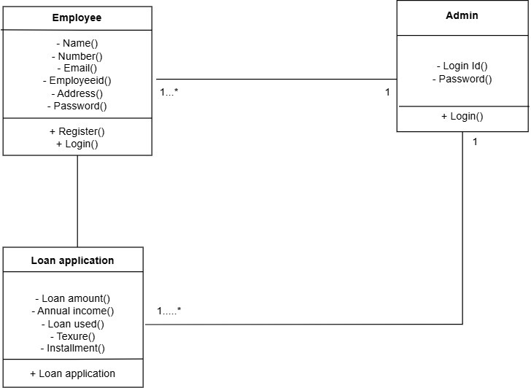

Use case diagram

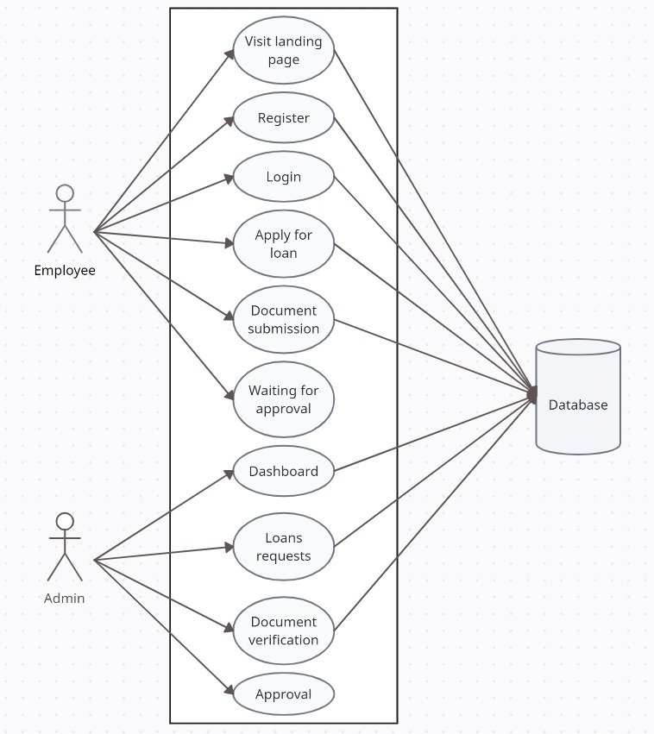

Activity diagram

